Changes to the GP access centre
at Alexandra Avenue - What our patients think?
June 2019

It has been seven months since the GP access centre at Alexandra Avenue Health Centre changed from being a walk-in and wait service, to an appointment only service for Harrow residents.

We wanted to find out what patients thought of the change to the service.
This paper covers the responses received.
Summary

152 surveys completed in May 2019

Seven out of ten people attending the GP access centre had been aware of the condition they needed help with for more than two weeks

Eight out of ten people received an appointment (86%) at the GP access centre within two to three days
Six out of ten people received a same or next day appointment
Patients that waited longer than three days were asked to leave a comment, all of the 36 comments left stated that they had either chosen the date, or they were attending an annual check-up.
Seven out of ten people knew they needed to book an appointment for the GP access centre, the same number thought their appointment was extremely or very convenient for them
Nearly everyone (96%) of people thought the time they had to wait when they arrived at the GP access centre was reasonable
Of those that had previously used the walk-in (two out of three respondents).
Six out of ten thought booking an appointment improved the service

Patients that did not agree with the change said: “a walk-in was still required.” 23 respondents (1.5 out of 10), left a comment along these lines.
Eight out of ten people rated their experience at the GP access centre as very good or excellent.
Methodology
The survey was conducted during the last two weeks in May 2019, seven months after the GP access service changed at Alexandra Avenue Medical Centre.

The survey was predominantly filled in face-to-face with patients 150/152 surveys, but to ensure a wide range of people had the opportunity to share their views the survey was:

- Shared with 350 organisations across Harrow, via the Harrow CCG engagement lead

- Published on the Harrow CCG website
- Promoted through twitter
- Press release sent out, with coverage in the Harrow Times and Hillingdon Times.
- The survey was also made available through reception at Alexandra Avenue Medical Centre.

Engagement leads from the NW London Collaboration of CCGs visited Alexandra Avenue on:

- Wednesday 22May: 1pm – 4pm
- Wednesday 29 May: 11am – 4pm
- Saturday 18 May: 11am - 12pm
- Thursday 30 May: 2pm – 6pm
- Friday 31 May: 1pm – 4pm

The survey questions
- Following your most recent visit to Alexandra Avenue - how long were you aware of the medical condition you asked for help with?

- Did you try and book an appointment with your own GP first?

- How did you get your appointment booked at the Alexandra Avenue?

- Did you know you needed to book an appointment?

How long did you have to wait for an appointment from the time you tried to book one?

How convenient was the appointment time you were able to get?

How long did you have to wait for an appointment from the time you tried to book one?

How convenient was the appointment time you were able to get?

- During your recent visit to Alexandra Avenue - did you feel the time you had to wait to be seen by a GP/nurse was reasonable?

Had you used Alexandra Avenue GP access centre before the changes were made in October 2018?

If you answered yes to Q8, do you think booking an appointment time slot has improved the service offered to you?

Overall how would you rate your experience of visiting Alexandra Avenue?

The results

Following your most recent visit to Alexandra Avenue - how long were you aware of the medical condition you asked for help with?
- 40% of patients attending the GP access centre had been aware of their condition for more than two weeks, 32% for more than a month
- 33% of patients had become aware of their problem the day they sought help from the access centre.

Did you try and book an appointment with your own GP first?

- 66% tried to book an appointment with their GP first

How did you get your appointment booked at the Alexandra Avenue?
- 59% booked their access centre appointment through there GP
- 11% turned up and 26% came via other services
- Just 3% called 111

Did you know you needed to book an appointment?

71% of people knew they needed to book an appointment first

How long did you have to wait for an appointment from the time you tried to book one?

- 35% received a same day appointment
- 18% booked the appointment the day before
- 28% waited two to three days for an appointment
- 19% *waited longer than three days
*Patients that waited longer than three days were asked to comment on if there was a reason – all of the 36 comments left stated that they had either chosen the date as it was unimportant, or they were attending an annual check-up.

How convenient was the appointment time you were able to get?

- 15 said extremely convenient
- 56 said very convenient
- 21% said somewhat
- 5 said somewhat
- 3 said not convenient at all

During your recent visit to Alexandra Avenue - did you feel the time you had to wait to be seen by a GP/nurse was reasonable?
- 7% said extremely reasonable
- 60% said very reasonable
- 30% said somewhat reasonable
- 2 said not reasonable
- 2% said unacceptable

Had you used Alexandra Avenue GP access centre before the changes were made in October 2018?

- 64% of survey respondents had previously used the walk-in service before the change

These respondents were asked, do you think booking an appointment time slot has improved the service offered to you?

- 59% said yes
- 41% said no
- Respondents also left a selection comments.

23 comments were in favour of keeping a walking service, 19 comments stated people were either happy with the service as it is now or happy with either.
Summary comments - all collected in the waiting area at Alexandra Avenue
- “Only used once and I was I in quickly”
- “The whole idea of a walk-in clinic, people expect to have to wait a little sometimes. By changing it to book only appointments, it might as well just be a normal poorly run, run of the mill, doctor’s surgery. Where you can’t get an appointment for love nor money.”
- “Prefer now with appointment service.”
- “Preferred walk-in, able to just come in and see the doctor. Now I had to call my GP many times and waited few days until I got here.”
- “I support this - and very happy. I got an appointment on the same day.”
- “Avoid A&E, walk in was much better with childcare.”
- “It has improved it immensely.”
- “Is great to have both - I was happy with walk in and now happy with appointment.”
- “Prefer walk-in, easy process just used to walk in. Now is more complicated - I needed to see my GP yesterday and they book me in for today, walk in more convenient.”

One comment was emailed to harrow CCG:
“I gather from the "Harrow Times" that you are seeking views on people's experience of the Centre.
I have been using the Centre, as a registered patient, since it opened. I can only say, that since the changes, it has been easier to obtain appointments. I have also been seen closer to the booked time, and the doctors have been better placed to give me their attention and talk through treatment options. It is a much better system.”

Overall how would you rate your experience of visiting Alexandra Avenue?

- 80% rated their experience as very good or excellent
- 15% said it was excellent
- 65% said it was very good
- 1% poor
- 8% left mixed comments about the service

Summary comments
- “Excellent before as a walk-in, and now is good”
- “Not used the service before”
- “Don’t know I am still waiting”
- “Along with the change of appointments, the service is totally useless as any medication needs to be done via my surgery, the service has become useless”
- “The service is brilliant”
- “Dr`s are very good but the service not so good”

The survey was completed by an:
- Equal mix of male and female respondents
- Equal mix of respondents through the age ranges, the 18-24’s were under represented in responses
- Equal mix of white and black minority ethnic respondents
- 40% of respondents had caring responsibilities
Tables below:
Age
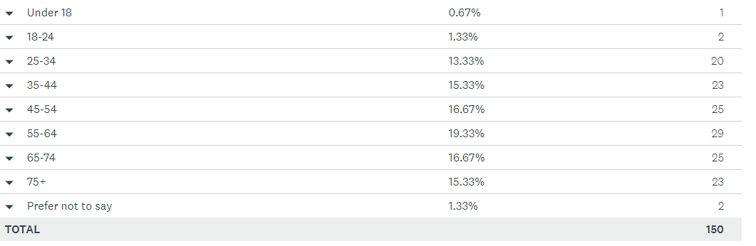
Gender
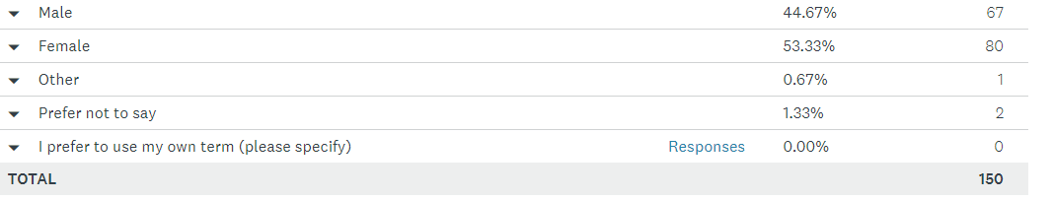
Is you gender identity the same as at birth
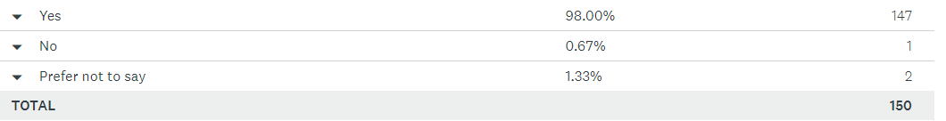

Sexual orientation
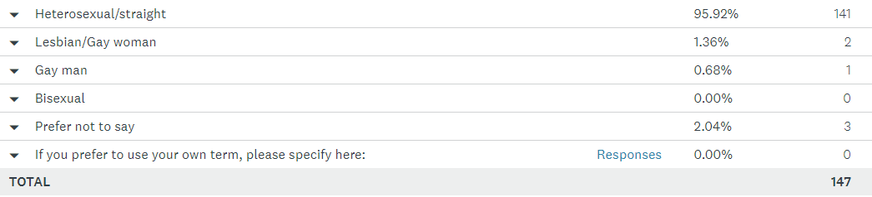

Ethnicity
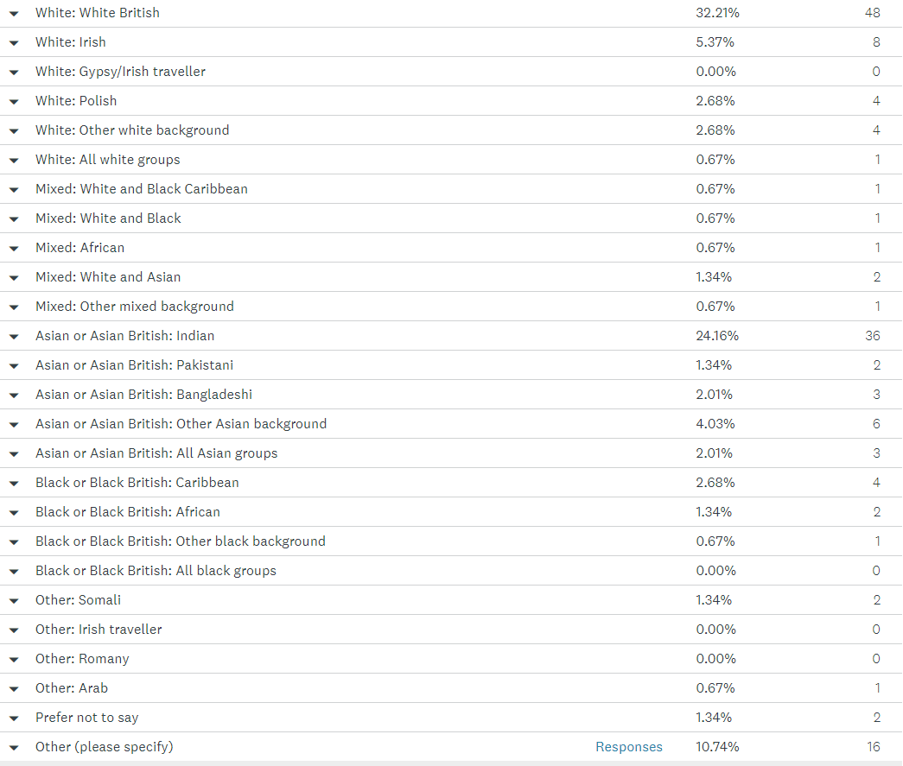

Religion
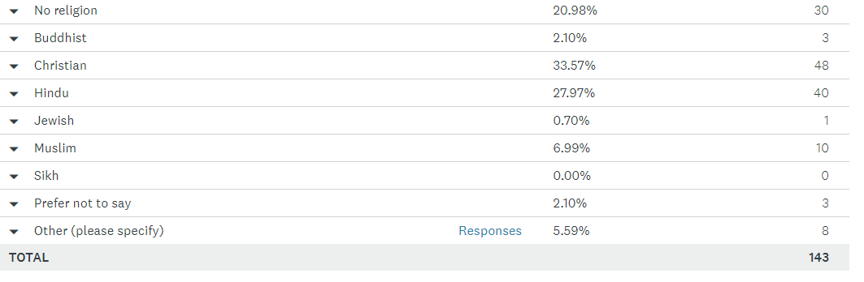
Caring responsibilities
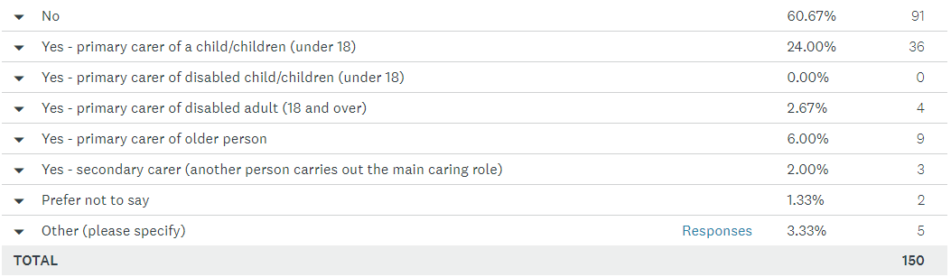

ENDS

